Cyber Security – Physical Security

Cyber Awareness Campaign - Part 3
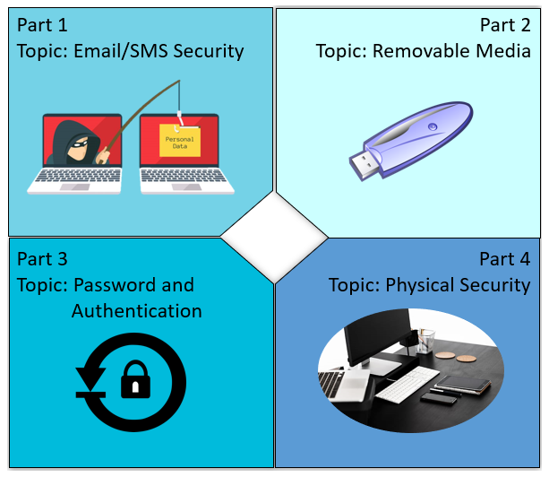
Cyber Security is the practice of maintaining
confidentiality, integrity, and availability of digital
assets like data and devices.
A cyber-attack is when a malicious third party
intentionally infringes on these principles for the
purposes of impacting a business or organization,
usually with the intent to extort money or sell data.
What is the G.James Cyber Defence system?
Defence | Description/recommendation
Username & Passwords | Should contain up to 8 characters including capitals, symbols
Multi-Factor Authentication (MFA) | Code sent to a phone or email to verify your identity
Network & Device Defence Systems | Anti-virus, Firewalls, Alert Monitoring, Anti-spam
Policy procedure and practice. | Well-defined practises and user knowledge is always the strongest defence.

Cyber security is a team effort.

Physical Security
- Physical security relates to who is in the environment, and why.
- Unauthorised or inappropriate access to IT systems could compromise data, deploy malware or cause damage resulting in downtime.
- Devices without login requirements (Factory machines) are most at risk.

Risk of compromise
When bad actors gain physical access to an area, they circumvent some of the networks defences that a company has in place. However, this makes the Bad Actor vulnerable to detection by camera or staff.

Likely perpetrators

People most likely to commit these acts:

Disgruntled employees past or present.

Bad actor from a rival company, or monetary incentive.

Users who are not trained, incompetent or confused.

Best Practices
- Visitor logbooks should be strongly enforced.
- Devices in public areas should be secured and never left unlocked when unattended.
- Unattended devices should be locked logged out or turned off when not in use.
- Kiosk built (auto login devices) should be secured and closely monitored.
- Employees should be trained and encouraged to confront anyone they do not know or who looks out of place. If necessary, confirm with a manager or team leader.
- Uniforms and PPE with Logos should be used by staff to help identify who should be in the environment and these outfits should not be attainable by the general public.

Division: |  | Branch
Workplace / Site location:
Presenter: |  | Date:

Employees Present:
Name | Initial | Name | Initial

Questions, concerns, and issues raised:

Actions:
Raised by | Description of Issue | Actions / Rectifications | Follow up required (details, person and date)
Signed: |  |  | Distribution:  - Branch Manager  - Health & Safety Coordinator
Date:

